Kirkintilloch Baptist Church

Fire Safety Policy

Document Amendment Record

Date of Review | Summary of Amendments
June 2018 | KBC Fire Safety Policy V1
February 2019 | KBC Fire Safety Policy V2
June 2019 | Schedule 2 – Fire alarm action & wilful fire raising 6thirty live
August 2019 | Schedule 2 diagram

Feb 2021
July 2023 | Update re new fire brigade call out procedures
Nov 2023 | Update re investigating the fire ourselves following new Scotland fire brigade response legislation
March 2025 | Minor changes, spelling / repeat words etc . also updated Document Author to Ruth Mitchell and made Alaistair Deacon part of the approving committee due to his time constraints.
May 2025 | Added in section specific to Sunday group evacuation
May 2025 | Added in an extra welcomer and their role, added in role of operations manager on a Sunday morning, removed double doors in large hall, added in schedule 4 to include warehouse evac plan, corrected main hall name to Large Hall and all Sunday school to re called Sunday groups. Amended description of stewards based on where they uptake the offering.
June | Chair of deacons has made various comments which we have corrected. Agreed to share policy with all group leaders and staff once approved
Nov | Changed the stewards annotations on fire plan for Sundays

Approving committee/group | Alaistair Deacon  Maureen Young  Gordon Paton
Document author | Paul Hogg  Ruth Mitchell
Named Officers | At time of last document review
Nominated Fire Officer | Ruth Mitchell
Fire Safety Advisor | Paul Hogg

List of Contents

1. KBC FIRE Safety Policy

1.1 Statement of Intent
1.2 Duty of those working for KBC
1.3 Formal control of fire
1.4 Commitment

2. organisational arrangements

2.1 The Trustees
2.2 Nominated Fire Officer
2.3 The Deacons
2.4 Deacons and Group Leaders
2.5 The Fire Safety Advisor
2.6 KBC group leaders or Employees with duties related to contractors
2.7 All KBC Employees and group leaders

3. control methods

3.1 Site Fire & Evacuation Procedures
3.2 Fire Risk Assessments

4. FIRE ALARM SYSTEM

SCHEDULES
Schedule 1 KBC Fire Evacuation Procedure
Schedule 2 Fire Alarm Action – The Stewards on Sunday duty
Schedule 3 Fire Alarm Action – Office Staff
Wilful Fire Raising

Fire Safety Policy
1.1 Statement of Intent
Kirkintilloch Baptist Church (KBC) aims to minimise the risk from the effects of fire to all persons who use its premises by promoting and actively pursuing a high standard of fire safety and fire protection.
KBC has developed and implemented a number of control procedures for the promotion and maintenance of effective fire safety, together with a system of review, which will ensure that this Fire Safety Policy remains effective with regards to all fire risks within KBC.
1.2 Duty of those working for KBC
All staff, contractors or self-employed people working for, or on behalf of KBC, must comply with the Fire (Scotland) Act 2005 and the Fire Safety (Scotland) Regulations October 2006 and all relevant guidance in Scotland to ensure the risk of fire is kept to a minimum.
Where anyone noted above discovers a fire or suspects that a fire exists, they must take appropriate action to raise the fire alarm.
All staff and group leaders must familiarise themselves with the fire procedures and adhere to them.
Note 1: From 1 July 2023, Fire brigades no longer attend automatic fire alarm (AFA) call outs to commercial business and workplace premises, such as factories, offices, shops and leisure facilities - unless a fire has been confirmed.
Keyholders with responsibility for workplace/church premises should safely investigate a fire alarm before calling 999, as the control room operators will ask for confirmation of an actual fire, or signs of fire, before sending the nearest resource.
1.3 Formal Control of Fire
The control measures required to effectively manage the risk of fire are described in Section 3 of this document.

1.4 Commitment
This Fire Safety Policy has the full support of KBC Trustees Elders and Deacons, but it is dependant on the support of all staff to ensure its continuing effective operation.
Therefore, the co-operation and commitment of every member of staff is essential.

2. Organisational Arrangements
The effective implementation of the KBC Fire Safety Policy requires participation by everyone. The main responsibilities for fire safety are summarised as follows:

2.1 The Trustees
The KBC Trustees have the overall responsibility for all fire safety and are responsible for:
- Establishing a Fire Safety Policy that is signed, dated and current.
- Ensuring that the policy has been communicated to all staff and is being implemented through a system of delegated responsibilities, is periodically reviewed and its implementation monitored.
- Ensuring that all staff give due care and attention to fire safety matters and have delegated to their team, where required, specific responsibilities in the event of fire or a fire alarm sounding.
- Ensuring that each group of building users is using the standard evacuation procedures or has a specific fire procedure if necessary.
- Ensuring that agreed programmes of investment in Fire Safety are included in financial plans.
- Ensuring that reports of fires, or near misses, are reviewed as appropriate.

2.2 The Nominated Fire Officer
The KBC Nominated Fire Officer may be a Trustee, Church Operations Manager, a Deacon, or on KBC staff with either adequate knowledge or ready access to specialist advice. They are responsible for:
- The overall strategy of KBC in fire related matters.
- The application of the Fire (Scotland) Act 2005; and the Fire Safety (Scotland) Regulations 2006.
- Liaising with the KBC Trustees to ensure the KBC Fire Safety Policy is understood and implemented.
- Ensuring an annual fire risk assessment is undertaken.
- Supervising the implementation of the Fire Safety Policy, in conjunction with other KBC staff.
- Receiving reports of all fire incidents, issues or near misses and where necessary informing the deacons of the details of the incident and, where necessary advising changes.
- Advising the deacons of measures necessary to ensure compliance with the requirements of Fire Safety Legislation.

2.3 The Church Operations Manager
The KBC Church Operations Manager (with support from the Deacons) directly, or through designated others, is responsible for:
- Maintaining and testing of fire detection equipment and firefighting equipment.
- Keeping up to date records of the maintenance and inspection of fire detection equipment and firefighting equipment.
- Supervising on a day-to-day basis the application of the Fire Safety Policy.
- Assisting in co-ordinating actions in the event of a serious fire in accordance with the Fire Safety Policy.
- Liaising with the Fire and Rescue Services in the event of a fire.
- Liaising with the Nominated Fire Officer on all aspects of fire safety.
- Submitting reports of all fires incidents, issues or near misses, as soon as possible.

2.4 Deacons and staff
Deacons and staff are responsible for:
- Implementing the Fire Safety Policy in a reasonable and logical way within their areas of control and ensuring that all relevant statutory requirements are met.
- Identifying roles and responsibilities within their area of control through which the Fire Safety Policy will be implemented and, where necessary, allocating specific responsibilities to key personnel.
- Ensuring all staff demonstrate that they are adequately giving due care and attention to all aspects of fire safety.
- Ensuring, if required, specific fire procedures are developed, implemented and reviewed for their area of control.
- Ensuring all staff under their oversight know, understand and accept their individual responsibilities under the KBC fire policy, procedures and contingency arrangements.
- Ensuring all staff under their oversight attend relevant fire awareness updates or training on an annual basis.
- Ensuring accurate fire update/training records are kept.
- Ensuring any known faults or defects in fire equipment are reported immediately to the Deacons and promptly remediated.
- Liaising with the Nominated Fire Officer on all aspects of fire safety.
- Familiarising staff on appointment, and at regular intervals, with the KBC fire safety policy and fire procedures.

2.5 The Fire Safety Advisor
The Fire Safety Advisor is responsible for providing advice/assistance for the KBC Nominated Fire Officer, Trustees, Deacons, Church Operations Manager and staff on all matters pertaining to fire safety, such as;
- Carrying out fire risk assessments.
- Carrying out fire inspections and providing reports to the Nominated Fire Officer
- Carrying out an annual review of the Fire Policy.
- Assisting with the development of local fire plans and procedures
- Supporting the KBC Nominated Fire Officer and other staff.
- Delivering training and providing assistance to KBC staff on all matters pertaining to fire safety
- Preparing and sending reports on issues/fires with the Nominated Fire Officer.
- Providing guidance as requested.

Note: The Fire Safety Advisor and Nominated Fire Officer may be an associate of KBC or a contractor. The key requirements are suitable knowledge and experience to provide KBC with the assistance it requires.

2.6 KBC Staff with duties related to contractors
Everyone on KBC staff with duties related to contractors is responsible for:
- At the point of tendering for the service, considering the fire safety elements of the work activity and ensuring that prospective contractors propose adequate arrangements to manage fire safety.
- Monitoring the performance of contractors to ensure that the Fire Safety Policy plus any proposed arrangements are adhered to.

2.7 All KBC Staff
Everyone on KBC staff is responsible for:
- Taking all reasonable steps to ensure the risk of fire is kept to a minimum.
- Reporting any hazard, defect, malfunction or faulty equipment with regard to fire safety to the deacons or Nominated Fire Officer and warning others who may be affected.
- Familiarising themselves with fire evacuation procedures and the position of fire equipment, alarms, evacuation routes and assembly point.
- Taking appropriate action to raise the fire alarm where they discover a fire or suspect that a fire exists.
3. Control Methods
The Fire Safety Policy is implemented by applying the following procedures:

3.1 Site Fire and Evacuation Procedure
The site fire procedure provides general information relating to the overall evacuation of the premises and includes the following:
- Action to be taken by staff discovering a fire.
- Action to be taken by staff hearing the fire alarm.
- The fire alarm system.
A copy of this procedure is attached as in Schedule 1.

3.2 Fire Risk Assessment
The Fire Safety Advisor will carry out a fire risk assessment. Where necessary any recommended actions arising from the fire risk assessments will be communicated to the KBC Nominated Fire Officer for action.

4. Fire Alarm System

The fire alarm can be activated in two ways: -
- Smoke/heat detectors - automatic
- Fire alarm call points - manual

Staff should ensure that they are aware of the fire alarm call points in their area.

Fire alarm tests will be carried out once per week. If an alarm sounds for more than 60 seconds then the test is over and the alarm must be considered real.

A full log/record of these tests will be kept.

Signed: on behalf of the Trustees
Date
SCHEDULE 1

KBC Fire Evacuation Procedure

1. Action to be taken by anyone on discovering a Fire in KBC

IMMEDIATELY

a) Operate the nearest fire alarm control point by breaking the glass.
b) Dial 999 and inform the operator of the EXACT location of the fire.
c) If safe to do so close all doors and windows to isolate the fire and prevent the passage of smoke

On the activation of the Fire Alarm all staff and visitors will evacuate the building via the nearest exit and report to the assembly point – the paved area between Sainsbury’s and East Dunbartonshire Voluntary Action office. Once evacuation has occurred, Stewards (or staff) will position themselves outside exits to ensure no one re-enters the building until given instruction by a member of the Scottish Fire and Rescue Service, or fire warden that it is safe to do so.

2. Action to be taken by Staff on Hearing the Fire Alarm

Staff should take action as detailed in the general KBC fire procedures, and those specific for their group.

  - The fire warden on that day will investigate the fire as per the fire procedures.
  - The staff in each area must ensure everyone in their group/area follows the general KBC fire procedures, and those specific for their group.

  - In the event of a fire at night, or when the building is unoccupied, IQ Services autodialler will attend on site and investigate the source of the fire and if there is evidence of a fire, they will contact the Scottish Fire and Rescue Service.

3. All Staff/group leaders

All Staff/group leaders must make themselves familiar with the following, in their own activity areas:

- Fire Exits
- Fire Extinguishers
- Fire Alarm Call Points
- Fire Zones
- Fire Assembly Points (the paved area between Sainsbury’s and East Dunbartonshire Voluntary Action office).

During any fire evacuation:

- Do not panic
- Use the nearest available Fire Exit
- Do not run
- Do not use the lifts
- Do not stop to collect any personal belongings
- Do not re-enter the building unless advised to do so by a member of the Scottish Fire and Rescue Service.

Remember you may know the building well, but visitors do not.

- Arrangements for Disabled attenders

Assistance for any regular attenders who have mobility problems will be provided in accordance with the PEEP’s agreed for those individuals.
SCHEDULE 2

Fire Alarm Action – The Stewards and caretakers on Sunday duty
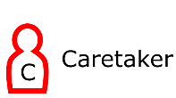
Caretaker Evacuation Procedure

In the event of the fire alarm being activated, the caretaker should go straight to the fire panel and identify where the fire is. They need to investigate the alarming area. If there is evidence of a fire, they should call 999 (we have a linked system, but now this needs to be confirmed with the fire brigade before they will attend so you must call 999).
If they can see that the fire was obviously a false alarm they should go to the fire panel, silence it, re set it and then go outside to the evacuation area and let everyone know it is safe to re-enter the building.
If the fire is genuine, after they have called 999, The caretaker should remain at the panel (provided it is safe to do so) to direct the Scottish Fire and Rescue Service to the activation location.

Steward Evacuation Procedure

In the event of the sounding of the fire alarm the Stewards / Welcome Team members on duty have a responsibility to assist with an orderly evacuation of the Church Building straight away (while the caretaker is investigating the alarm).
Currently there are 2 Stewards and 3 Welcome Team members on duty at each service which should be deployed as follows:

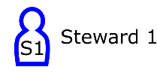
- The Steward responsible for taking up the offering on the Sainsbury’s car park
side of the auditorium.

  - This Steward should stand at the Emergency exit at the side of the stage in the Sanctuary. From there they should:
    - encourage an orderly evacuation of the congregation at the front of the Sanctuary via the emergency exit at the side of the stage. They should continually tell those exiting to meet at the evacuation point between Sainsbury’s and EDVA. This way the whole congregation will come back together irrespective of where they exit.
    - assist the physically disabled to exit the Sanctuary. Ideally the Sainsbury’s car park entrance would be their fastest exit option, and this is in their PEEP. Where this is not possible but after all abled bodied people have exited the emergency exit next to the stage, the steward should set out the ramps to assist those with physical disabilities to leave the Sanctuary via emergency exit next to the stage. The ramp sits behind the prayer flag and chairs.

  - Thereafter they should:
    - close the emergency exit to ensure that nobody tries to re-enter the building.
    - Then proceed to the assembly point.

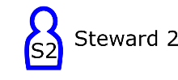
- The Steward responsible for taking up the offering on the Townhead side of the auditorium.

  - During the evacuation of the children from the classrooms this steward should stand in the Townhead vestibule in front of the door which accesses the stairwell that connects the classrooms and Greenhouse. (there is a turnkey now located in the Townhead main entrance to save you needing a key.)
From there they should: -
    - encourage an orderly evacuation of the congregation coming from the Sanctuary out through the Townhead door. They should continually tell those exiting to meet at the evacuation point between Sainsbury’s and EDVA. This way the whole congregation will come back together irrespective of where they exit.
    - ensure that nobody tries to use the lift
    - ensure that nobody tries to access the stairwell (the stairwell is being used by the children evacuating from the classrooms).
    - ensure that nobody from the stairwell tries to access the Townhead vestibule but exits through the fire escape at the bottom of the stairs.
  - Once the evacuation at the Townhead side has been completed this steward should stand on the pavement at the Townhead entrance to ensure that nobody tries to re-enter the building until the fire service has advised it is safe to do so.

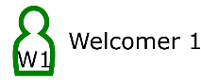
- The welcome person stationed on the Sainsbury’s car park side.

  - This welcomer should encourage an orderly evacuation of the congregation on the “car park” side of the Sanctuary via the car park entrance.
    - They should ensure the “car park” entrance door is off the latch and both doors able to open to ensure a smooth exit of the congregation.
    - They should continually tell those exiting to meet at the evacuation point between Sainsbury’s and EDVA. This way the whole congregation will come back together irrespective of where they exit.
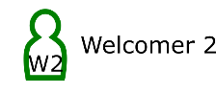
- The welcome person responsible for covering the welcome desk

Please support the steward in the Townhead vestibule/beside the lift. Reassuring parents, they will be able to meet their children at the EDVA meeting point, and encouraging adults to use the right-hand side of the staircase out of the Townhead doors.

- Welcome Team member stationed on the Townhead side. W3

  - This Welcome Team member should encourage an orderly evacuation of the congregation on the “Townhead” side of the Sanctuary via the Townhead entrance.

    - They should ensure nobody leaving the “Townhead” side of the Sanctuary tries to exit via the car park entrance or the large hall as these escape routes are being used by those on the “car park” side of the Sanctuary and part of the Sunday groups.
    - They should continually tell those exiting to meet at the evacuation point between Sainsbury’s and EDVA. This way the whole congregation will come back together irrespective of where they exit.
    - If is not safe to leave via the Townhead entrance or car park exit they should ensure that people exit via the emergency exit in the large hall to leave the car park entrance available to those exiting the Sanctuary on the other side.
  - Once the Sanctuary has been evacuated the Welcome Team member should:
    - check that the large hall has been evacuated.
    - exit the building through the emergency exit in the large hall.
    - close the emergency exit behind them to ensure that nobody tries to re-enter the building, and
    - proceed to the assembly point.

- Operations manager

In the morning service, the Operations Manager will take on the fire warden role and be the link between outside and inside. They should inform those waiting outside, whether there is indeed a fire and we are having to wait for the fire brigade or whether the church family can come back in following the alarm being silenced. On Sundays when the operations manager will not be there, they should inform the Sunday steward co-ordinator and the chair of the deacons. The operations manager will wear a hi-vis vest (situated at the fire panel) and so whoever is covering for them will wear this, so it is obvious to others who has assumed the role.

Morning Evacuation Map

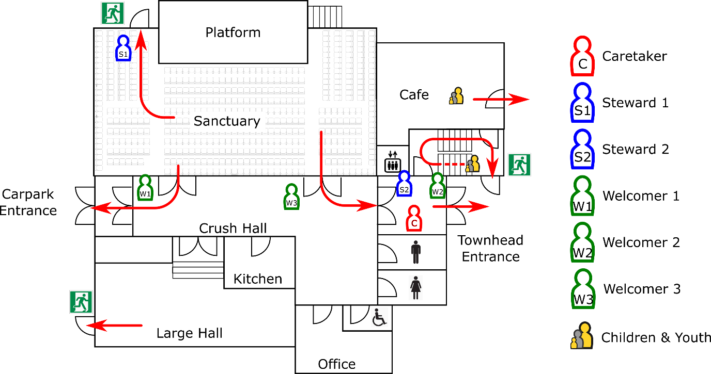

Sunday evenings evacuation

The evacuation is much simpler as those at the service are all in the sanctuary. Please use the sanctuary fire exit beside the stage and the Sainsbury’s car park entrance as the main routes for evacuation. If there are no caretakers on duty then a member of the KBC staff team should go to the fire panel and assume the role of caretaker. If needed, then the Townhead exit can be opened using the turnkey or the LG stairwell fire exit beside the café can be used.

Sunday evening evacuation Map

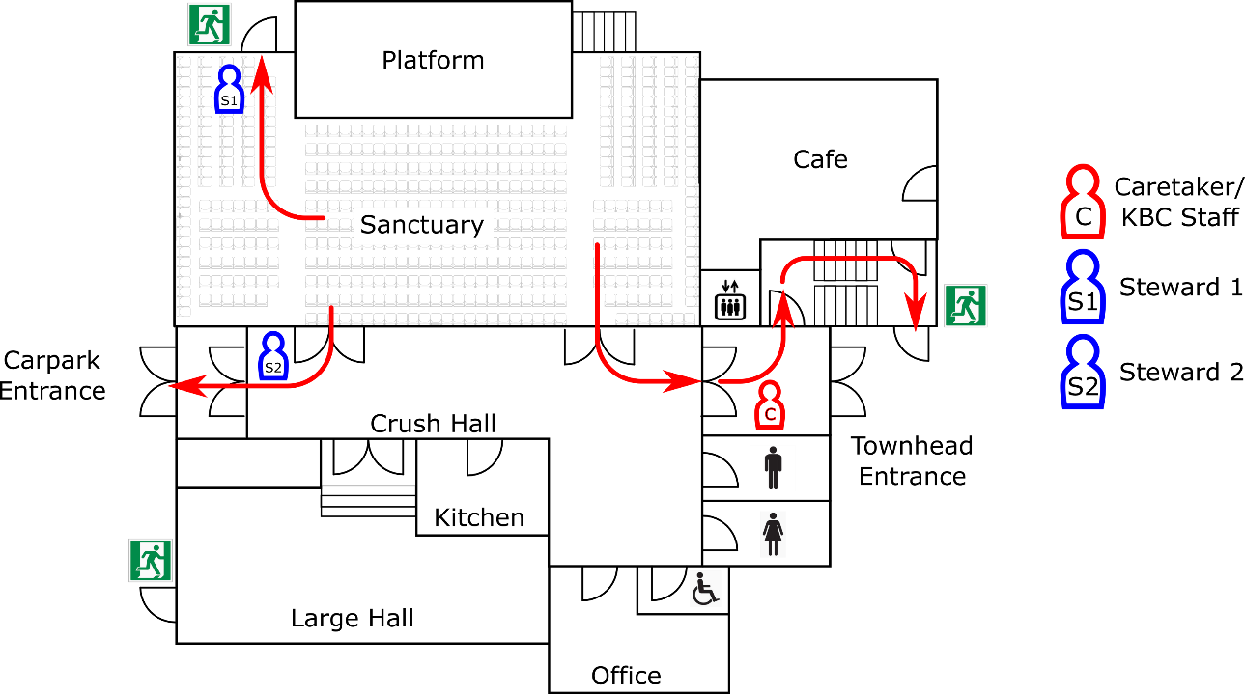

Route to Evacuation point at EDVA

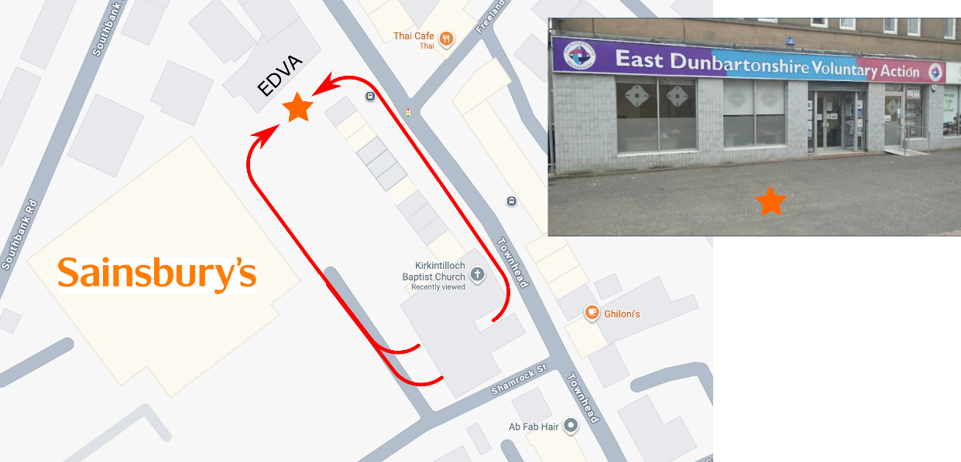

Relay hall

While the relay hall has less than 80 attendees, no steward will be expected to lead the evacuation as there is an obvious means of escape through the fire exit in there. Once we have over 80 in there, I would expect we would need more stewards on duty if the building as over 500 people in it at one time or an acting steward will be appointed from home groups each week. It is already part of the current morning evacuation to include a large hall check by one of the welcome team. (W3)

SCHEDULE 3

Fire Alarm Action – Office Staff and Greenhouse staff

Should the fire alarm activate during a weekday the Office and Greenhouse staff will:

- The caretaker and/or operations manager (the administrator should do this when Operations manager is not in office) will identify the location of the activated alarm point to establish where the fire is. They should go to this area and see if they can identify a fire. If there is a fire or they are unable to identify the risk, they should call 999 and call out a fire engine.
- No one should attempt to tackle a fire any larger than a waste paper bin.
The caretaker should dial 999 advising the emergency operator where the fire is and what evidence they have seen of the fire. This is essential as a sounding alarm no longer calls out the fire brigade.
If you have found the source and it is a false alarm (eg burnt toast), then go to the fire panel, silence the alarm and re set it. Then go to the assembly area and inform everyone they are safe to return to the building.

- All office and greenhouse staff will leave the building via their nearest exit and assemble on the paved area between Sainsbury’s and East Dunbartonshire Voluntary Action office.
- Greenhouse staff in the kitchen should switch off the panini toaster before leaving the area.
- The first person going out the car park doors should take the Sign In/Out board with them and then conduct a roll call based on who is signed in the building. If anyone is missing this should be passed on to the attending fire service. In the event that no one passed through the car park doors, either the caretaker or Operations manager should take this out to the evacuation meeting point.
- IQ security Services will attend on site if out of hours.

SCHEDULE 4
Fire Alarm Action – Foodbank Warehouse

The warehouse now has its own fire alarm system so when the fire alarm sounds, all volunteers should proceed out the warehouse and assemble in the car park in front of Kenwil. The member of staff on duty in the warehouse should try to find evidence of the fire and call 999 if they find one. If they can see what has triggered the fire alarm but it is able to be managed by use of the fire extinguisher, then they should attempt to do so if they feel comfortable with this. They can then silence the alarm and let the volunteers know they can re-enter the warehouse.

WILFUL FIRE RAISING (ARSON)

Wilful Fire Raising is defined as the unlawful damage by fire of property belonging to another. Although the term ‘arson’ may be encountered in common usage it is not a term that is recognised in Scotland to describe the offense of wilful fire raising.

Whilst wilful fire raising cannot be fully preventable, actions can be taken to minimise the risk to the lowest practicable level taking into account all circumstances. Security arrangements and fire detection systems are put in place to prevent unauthorised entry into buildings/areas and to enable prompt response in the event of a fire. Alertness towards general security principles including prompt removal and safe disposal of combustible waste sources and ensuring that areas are kept secure and free from undetected/unauthorised persons will assist in preventing wilful fire raising activities. Suspicious persons or suspected activity should never be left unchecked or unreported; security awareness is intrinsically linked with wilful fire raising awareness.

KBC Staff have a responsibility to:

- Ensure that all reasonable and practical measures are taken to ensure that areas under their control are secured from unauthorised persons at all times (especially during non core hours of operation) and any periods where parts of the building are unoccupied;
- Minimise the accumulation of combustible materials by securing waste and other materials and following good housekeeping practices;
- Respond accordingly to any concerns raised by staff or visitors, etc that could elicit possible wilful fire raising.

All staff members have a responsibility to:

Respond accordingly to any wilful fire raising risk that they encounter which may include preventing the act initially by securing an area or removing accumulated combustible materials, or reactive response to a fire;
- Not wilfully damage or negate any fire safety measures e.g. wedge open unless manned or obstruct fire doors, extinguishers or break glass points or store combustibles in stairway enclosures or corridors;
- Report any risks in relation to wilful fire raising to the KBC Nominated Fire Officer;
- Report any unexpected strangers in controlled areas e.g. church office, particularly anyone displaying suspicious behaviour.

Smoke machines:

- If smoke machines are being used at FNL, at 7pm service or another event, the smoke sensors need to be deactivated in the auditorium due to the use of smoke machines. Stewards need to be more vigilant during these services.

